Meta Title:
Best Jewelry Store In Greensboro, NC | Crystal Jewelers
Meta Description:
Crystal Jewelers, a family-owned jewelry store in Greensboro, NC, offers a stunning selection of diamonds, precious stones, and elegant fine jewelry.

Crystal Jewelers: The Best jewelry store in Greensboro NC (h1)
Are you looking for the best jewelry store in Greensboro NC? Look no further! Crystal Jewelers is affiliated with a family that deals in amazing diamonds, gemstones, elegant timepieces, and designer jewelry. With immense pride, we are the one-stop shopping provider for all jewelry needs, combining innovation with quality, style, elegance, and high-quality designer jewelry that will turn you into the center of attraction.

Shop Now!

Witness a World of Luxury, Exceptional Service, and Unbeatable Value:
With a staff of master Greensboro jewelers, highly trained personnel, and professional consultants, Crystal Jewelers is committed to helping you select the piece you desire. Thanks to our offering, professionalism, and the guarantee of quality, and affordable prices our company has the title of the “best jewelry Store near me” in Greensboro, NC. It’s time for you to get the best that you rightly deserve, so let’s go get it!

Visit Today!

Discover the Timeless Elegance of Diamonds:(h2)
Diamond engagement rings are not only a girl’s friend but a symbol of your affection and loyalty. The carrying out of any shaping is not a problem for our custom jewelers Greensboro experts who are skilled craftsmen and can help in choosing the right shape of diamonds. Starting with the main and traditional round cut diamonds, up to the king-like sparkle of the princess cut diamond, we have got you covered in all the various diamond shapes that you could ask for:
1) Round: The Timeless Classic
2) Princess: A Royal Choice
3) Oval: Graceful and Feminine
4) Cushion: Warm and Cozy
5) Pear: a perfect cocktail of glamour and style.
6) Emerald: Elegant and Timeless
7) Heart: An Eternally Romantic Choice
8) Radiant: Modern and Eye-Catching
9) Asscher: Vintage and Art-Deco Inspired
10) Marquise: A Unique and Stately Shape

Boost Your Experience with Our Fascinating Time-Telling Devices! (h2)
Besides our impressive and comprehensive collection of jewelry at Crystal Jewelers, we also offer other fine timepieces. To ensure our customers are fully satisfied, our Jewelers Greensboro NC experts sorted through a vast assortment of classic timepieces from famous manufacturers such as Rolex, Omega, Breitling, and so many others. Whether you are looking for a sophisticated wristwatch to celebrate a special achievement or an elegant watch to be used daily, Crystal Jewelers timepiece selections will fulfill your needs and wants.

Explore Our Collections!

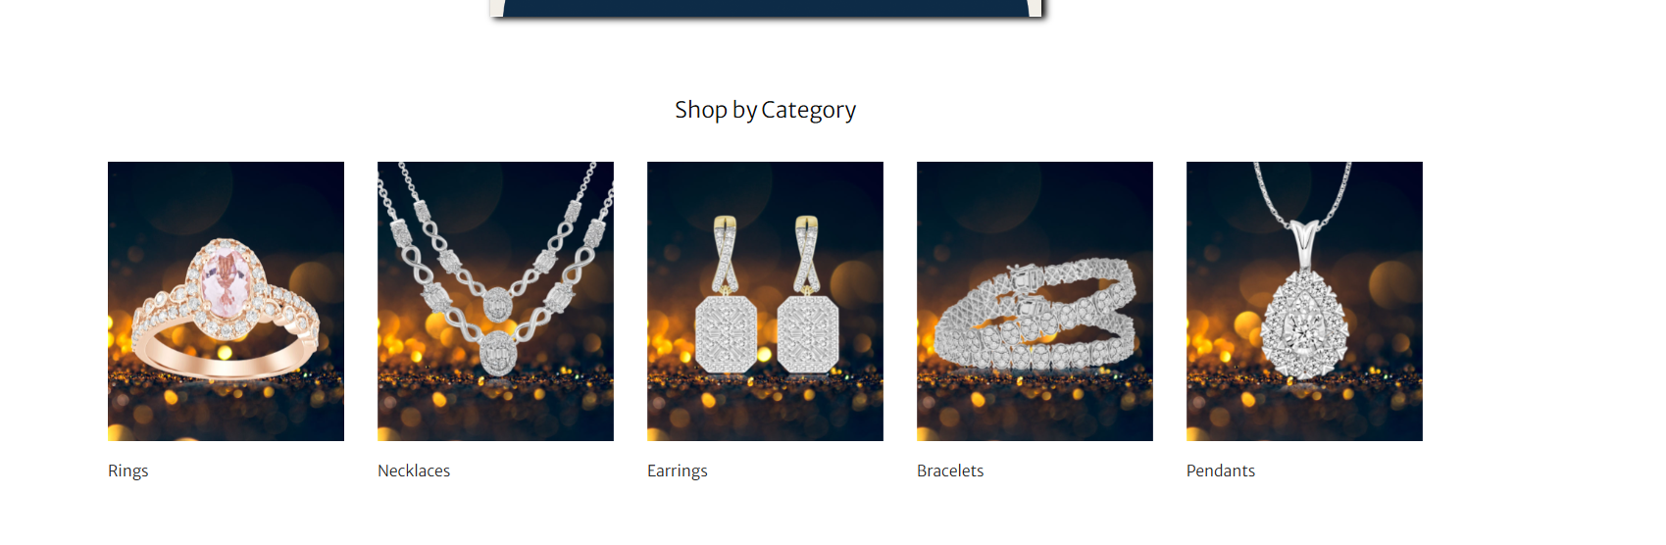Find Your Perfect Jewelry Piece by Category: (h2)
Our Diamond Jewelers Greensboro NC experts understand very well the excitement of finding that special jewelry accessory you like most. By dividing our jewelry collection into different collections, we will make it easier and more convenient for you to find that perfect piece of jewel at Crystal Jewelers.

- Rings: Here, you will find only the best rings in traditional solitaire or sylvan engagement that speak to your personality.

- Necklaces: Upgrade your fashion with our exclusive necklaces collection of unique pieces, exclusive gems, and timeless styles.

- Earrings: With earrings from our magnificent collection, you can upgrade your appearance and style as per your personality.

- Bracelets: Find our collection of bracelets that will help you complete your outfit with refinement and make a statement.

- Pendants: Seek Crystal Jewelers' best pendant to enhance the beauty and sophistication of your personality in a better way.

Unbeatable Deals and Exclusive Offers just for You!

Why wait any longer? Come to our store right now and meet the fabulous world of unique and beautiful jewelry pieces. Stocking the largest collection of sparkling diamonds, rare gemstones, and classic designs, Crystal Jewelers is your one-stop shop for all jewelry items. Welcome to Crystal Jewelers in Greensboro, NC where you will find the best quality along with the best value. There is nothing like our jewelry anywhere and we promise you that!



Own Jewelry Now, Pay Later!
Upgrade your purchase with Crystal Jewelers: order your desired jewelry and leave the rest up to us. Finance With Snap and get Up to $5,000 approval for gifts to Make those Special Moments Happen With Snap. No Credit Check Financing option offers you the chance to grab your jewelry now! Options of Klarna, Synchrony, Affirm, and Acima Leasing also available.

